1. Sorting in My sql (by using order by)

**SELECT**

select_list

**FROM**

table_name

**ORDER** **BY**

column1 [**ASC**|**DESC**],

column2 [**ASC**|**DESC**],

...;

1. Selecting 1st and last entry / entry by entry (use UNION and limit)

(select *from DemoTable694 order by EmployeeId ASC LIMIT 1)

UNION

(select *from DemoTable694 order by EmployeeId DESC LIMIT 1);

1. To Filter Data One Uses multiple times (use like)

select distinct city

from STATION

WHERE CITY like 'a%'

or city like 'e%'

or city like 'i%'

or city like 'o%'

or city like 'u%'

;

1. To compare values to null or empty

IS **NULL**

1. Adding columns in sql

**ALTER** **TABLE** **table**

**ADD** [**COLUMN**] column_name column_definition [**FIRST**|**AFTER** existing_column];

1. Nested if

SELECT N, IF(P IS NULL ,'Root' ,IF((SELECT COUNT(*) FROM BST WHERE P=B.N)>0,'Inner','Leaf')) FROM BST AS B ORDER BY N;

1. Proc sort data = products nodupkey;

By group_id;

Run;

**Create table abc as**

**SELECT**

product_id,

product_name,

**group_id**,

ROW_NUMBER () **OVER** (

**PARTITION** **BY** **group_id**

**ORDER** **BY**

product_name

)

**FROM**

products;

**select \***

**from abc**

**where (row_number == 1)**

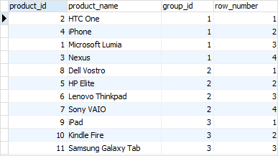

1. Merging

Create table merged_data as

Select a.*,b.*

From data as a left join data2 as b

On (a.col1 = b.col2)